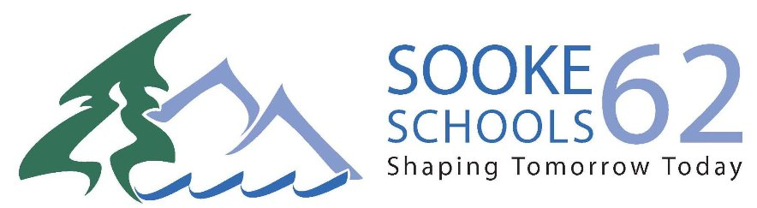
SCHOOL DISTRICT NO. 62 (SOOKE)
3143 JACKLIN ROAD,
VICTORIA, BRITISH COLUMBIA • V9B 5R1
TELEPHONE: 250-474-9800 FAX: 474-9825
WEBSITE: WWW.SD62.BC.CA

Return to School: How can you help us keep our schools, classrooms and community healthy?
SCHOOL DISTRICT NO. 62 (SOOKE)
3143 JACKLIN ROAD,
VICTORIA, BRITISH COLUMBIA • V9B 5R1
TELEPHONE: 250-474-9800 FAX: 474-9825
WEBSITE: WWW.SD62.BC.CA

June 1, 2020

Dear parent/guardian,

As we open schools to voluntary return for students, it is important for you to know that your child’s health and safety is our primary concern. Below are key considerations that we will need students/families to be aware of and observe while participating in our phase two return:

If your Child is Ill:

If a student is ill, with any common cold, influenza or COVID-19 like symptoms including:

- respiratory symptoms (shortness of breath and breathing difficulties)
- Cough
- Fever
- Chills
- Muscle pain
- Sore throat –
- Loss of taste or smell –
- Nausea, vomiting and diarrhea

parents/guardians must keep their child at home until they have been assessed by a health care provider to exclude COVID-19 or other infectious diseases, AND their symptoms have resolved.

If a student or staff member is assessed by their family physician or nurse practitioner and it is determined that they do NOT have COVID-19, they may return to school once symptoms resolve.

If you are unsure of your student’s status or if they have symptoms contact 811 for guidance.

If your child becomes ill while in School:

• As per guidance from health authorities, any child exhibiting COVID-19 symptoms will be moved to a special isolation
room, where they will be supervised and supported by staff until they are picked up.

• Parents /Guardians will be notified and advised to pick-up their child as soon as possible. Please ensure that the
school has your up to date contact information, including emergency contact information, to ensure timely pickup.

Be Accessible at all times: Please keep your phones on and yourself accessible if you are sending your child to school. If your child is unwell we will ask you to pick up your child/children.

Conduct Daily Self-Assessments:

Parents/guardians must assess their child daily for symptoms of common cold, influenza, COVID-19, or other infectious respiratory disease before sending them to school. If a student is ill, with any common cold, influenza or COVID-19 like symptoms, parents/guardians must keep their child at home until they have been assessed by a health care provider to exclude COVID-19 or other infectious diseases, AND their symptoms have resolved.

Illness in another Family Member: A student may NOT receive in-person instruction if another person in their home has symptoms of common cold, influenza, COVID-19, or other infectious respiratory disease, even though they remain asymptomatic. This will help keep our schools and community safer.

Drop Off/Pick Up Procedures

Parents/Guardians must remain outside of the school when dropping off /picking up students. Parents/ Guardians must not enter the school. Administration will develop drop off/pick up times and if the schedule needs to be modified based on student attendance this will be communicated to Parents/Guardians. For K-5 students the expectation to physically distance is shifting to that of minimizing/avoiding physical contact. However, physical distancing of 2 meters must be maintained by middle school students, secondary students and adults. In addition to the Daily Self-Assessment for Illness, Parents/Guardians of Learners with Diverse Needs, as required, will communicate with staff via email prior to arrival to communicate any additional information that may be needed regarding supporting their child. Please consult with case manager and administration if support is needed.

Access Control

Parent/guardians and visitors must not enter the school/site. Only School District No. 62 staff may enter.
Access to SD 62 sites by non-school district personnel is not permitted unless deemed necessary by administration or site-manger. Communication should occur via the phone, virtual meeting, or email. If access is required, it must be by pre-approval from administration or site-manager and by appointment only.

Food and School Supplies

Food and other supplies brought to school each day by students must be brought home at the end of each day. Please ensure that all food your child may bring to school is packed in clean containers. Students will be informed that sharing of food will not be permitted. Some school supplies may remain onsite, if requested by administrator or teacher, as long as, supplies are not shared and they do not inhibit the custodian’s ability to clean and disinfect

Handwashing

Handwashing is required for students:

- Before leaving home, on arrival at school, and before leaving school
- After using the toilet
- Before and after any transitions within the school setting (e.g. to another classroom, indoor-outdoor transitions, moving to on-site childcare, etc.)
- After sneezing or coughing
- After breaks and sporting activities
- Before and after eating any food, including snacks
- Before touching face (nose, eyes or mouth)
- Whenever hands are visibly dirty
To help maintain a healthy learning environment, we are continuing to ask students and families to practice good hand hygiene and respiratory etiquette (Coughing and sneezing into your sleeve). Please review with your child on a regular basis.

